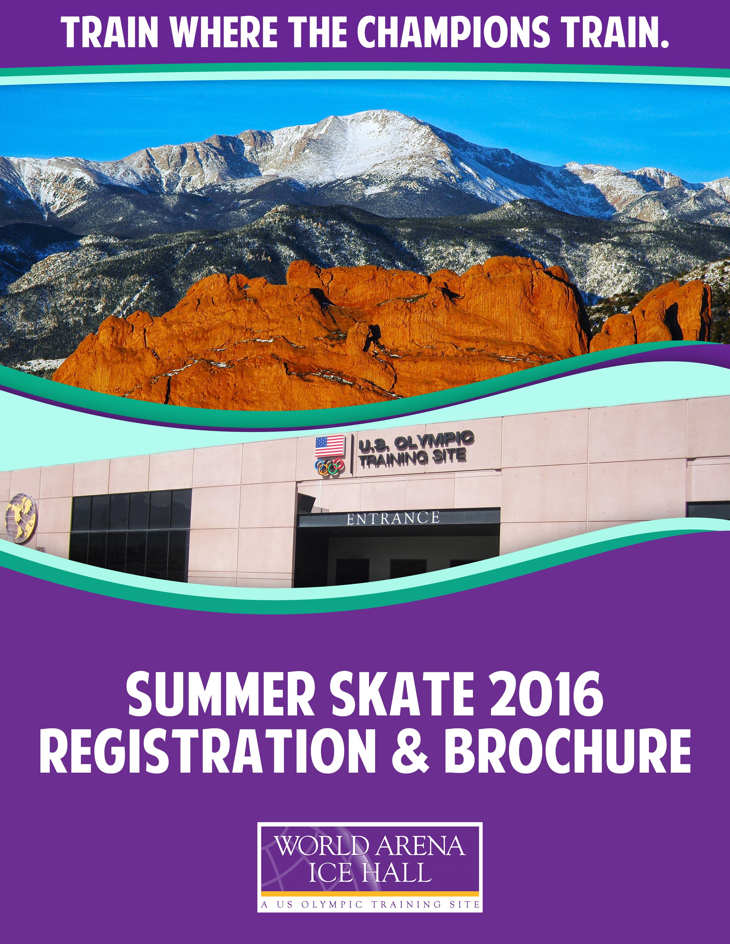About Our Facility

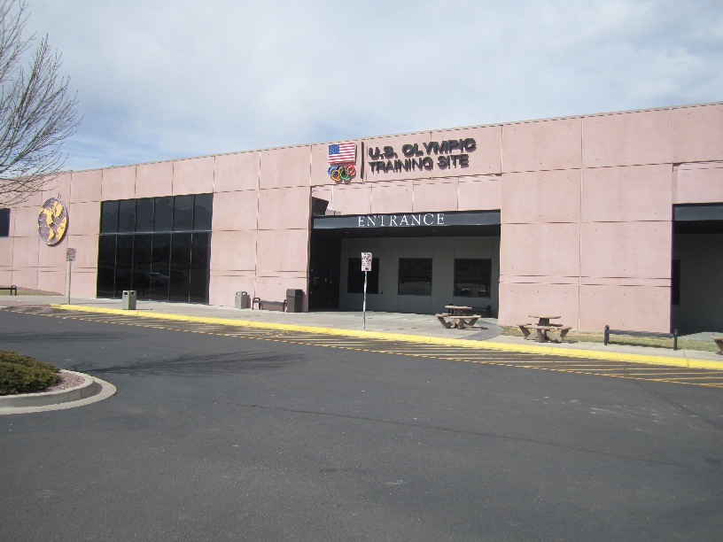
Thank you for your interest in the Colorado Springs World Arena Ice Hall – a U.S. Olympic Training Site – for your 2016 summer training. Each year our program attracts skaters of all levels from all corners of the globe. In recent years skaters and coaches have traveled to our training facility from Australia, Belgium, Canada, Dubai, England, Finland, Italy, Japan, Korea, Mexico, Sweden and South Africa.

Colorado Springs has long been the training ground for champions having produced 3 Olympic Champions, 7 World Champions, 5 World Jr. Champions and 58 U.S. National Champions —including 26 U.S. Champions at the Senior level. For the 2016 season, our facility had 22 skaters who qualified for the U.S. National Championship including 6 medalists. While you are here training alongside our champions, you will be working with some of the most accomplished teaching professionals in the world. The coaching staff and our administrative staff is ready to make your summer skating experience one that leaves you a more seasoned athlete and with a suitcase full of memories of the people you will meet!

The Colorado Springs World Arena is home to the Broadmoor Skating Club (BSC) which hosts multiple events during Summer Skate including the well-known Broadmoor Open (June 19-25, 2016). Fire and Ice Exhibitions are held on Friday evenings to give skaters the opportunity to perform their programs in preparation for competition. In addition, the BSC also conducts test sessions in the Ice Hall. For more information about any of the BSC events, please visit www.broadmoorskatingclub.com.

Two Ice Sheets-The Ice Hall provides approximately 30 skating sessions/classes per day on one Olympic-size and one NHL-size sheet of ice.

Excellence on Ice-The Colorado Springs World Arena Ice Hall is recognized by the Professional Skaters Association as one of only 30 Excellence on Ice facilities in the United States recognized for dedication to excellence in coaching both on and off-ice.

Dartfish- In addition to traditional video analysis, computer-aided video analysis using state-of-the-art DartTrainer technology is available every day.

Studio-Within the rink off-ice group classes are offered in a fully-mirrored studio with traditional wood floor.

Jump Harnesses- One off-ice harness, plus an additional on-ice harness in each rink.

Pole Harnesses- Our trained coaches will help you rehearse the correct technique.

NSCA-Within walking distance of the Ice Hall, the National Strength and Conditioning Association specializes in the utilization of proper strength training and conditioning to improve athletic performance and fitness.

A Piece of History-The Colorado Springs World Arena is minutes away from U.S. Figure Skating Headquarters, the Figure Skating Museum, the United States Olympic Training Center and the historic Broadmoor Hotel.

Figure Skating Sessions

Skaters who have not reached the Pre-Preliminary level must have completed the USFS Basic Skills Free Skate 1 level before they can skate on training sessions during Summer Skate. Monday through Friday, those skaters may skate the 5:55 am (NHL) and 6:40 am (NHL) Free Skate 1-Sr FS/Dance sessions, as well as the 5:30 pm (NHL) Free Skate 1-Intermediate FS session. On Saturday, those skaters may skate the 6:45 am (NHL) Free Skate 1-Sr FS/Dance session. Skaters must skate sessions that are for their tested freestyle level; not moves in the field! (Example: A skater that has tested Pre-Preliminary freestyle and has tested Juvenile moves may only skate sessions that are for Pre-Preliminary skaters.)

Figure Skating Session Protocol

- If a skater arrives for a skating session 5 minutes or later after the session start time, their spot may be taken by another skater on the waiting list regardless if they have contracted for the session. Skaters are asked to call the Skating Office at (719) 477-2178 to inform us they are running late so we can hold their spot.

- Session rosters are displayed each morning for the day on both the NHL and Olympic rinks. Skaters must check in with the ice monitor prior to getting on the ice.

- Pre-registered sessions/classes and/or contracted drop-in sessions/classes cannot be switched.

- Skaters must exit the ice immediately when their session ends and/or when the Zamboni appears at the door.

- There is no changing or bag storage in the lobby. Skaters are encouraged to use the provided Locker Rooms and Rinks for changing and bag storage. Lockers are provided in the Women’s and Men’s locker rooms, however skaters must provide their own locks. The Colorado Springs World Arena is not responsible for lost, stolen or damaged items left in lockers or the locker rooms.

Figure Skating Session Music Rules

Skaters practicing their program to music must wear the sashes provided by the music boxes on each rink. A skater or team whose program is being played and is wearing the sash has the right of way. Always yield the right of way to the skater(s) wearing the sash and performing their program. The skaters(s) wearing the sash need to be aware of others on the ice including coaches.

- Respect music in line at the music booth. NO changing order.
- Put music in line when you are ready to skate your program. No restarts or rewinds.
- To do your program a 2nd time, you must wait until everyone has gone 1 time.
- Skaters must wear the sash when skating to their music to help others to know they are in a program and have the right of way.

For questions or more information contact:
Bobbie Browning
Ice Hall Skating Office Manager
(719) 477-2153
bbrowning@broadmoorworldarena.com
Contracting Information
FREESTYLE SESSIONS

- Freestyle Skaters MAY NOT sign up online for sessions outside of their discipline.
- If you are a visiting skater, proof of current tested Freestyle Level may be requested by the Skating Office.
- Freestyle Skaters may skate up or down ONE level if:
  - There are ten (10) or less skaters including the individual making the request
  - No other comparable session is available for the skater
  - Skater has a lesson contracted
  - Skater informs the Skating Office staff and signs the roster
  - Skater MAY NOT sign up online for these sessions, they may drop-in only
- Freestyle Skaters may skate on a Dance/Pairs Session if:
  - There are three (3) teams or less skating, and a total of ten or less skaters on the session.
  - No other comparable session is available for the skater
  - Skater has a lesson contracted
  - Skater informs the Skating Office staff and signs the roster
  - Skater MAY NOT sign up online for these sessions, they may drop-in only

DANCE and PAIRS SESSIONS

- Teams will have priority on all Dance, Pairs and Dance/Pairs Sessions

- Freestyle skaters may skate on Dance, Pairs and Dance/Pairs Sessions with the following provisions:
  - There must be three or less teams and a total of 10 or less skaters on the session
  - No other comparable session should be available for the skater
  - Skater MUST have a lesson contracted, and be in a lesson the entire time they are on the session. If a skater is only in a 20-minute lesson, they must buy a 20-minute session ticket
  - No more than 10 skaters allowed on a session that contains freestyle skaters
  - Although standard music rules apply, Dance and Pairs skaters will have music priority
  - Skater MAY NOT sign up online for these sessions, they may drop-in only

- Students in a choreography lesson may have the option to use a Dance or Pairs session if the following criteria is met.
  - There must be three or less teams and a total of 10 or less skaters on the session
  - Skater MUST have a lesson contracted and be in a lesson the entire time they are on the session. If a skater is only in a 20-minute lesson, they must buy a 20-minute session ticket
  - Although standard music rules apply, Dance and Pairs skaters will have music priority
  - Skater MAY NOT sign up online for these sessions, they may drop-in only

On Dance only sessions, Pairs skaters may have the option of doing the session if space is available
On Pairs only sessions, Dance skaters may have the option of doing the session if space is available

Criteria for the National Freestyle session

US National Competitors

- Freestyle competitor who has competed at US Nationals (Novice-Senior) within the current competitive season

- Freestyle competitor who has received an International Assignment from U.S. Figure Skating for the current or upcoming season

- If space exists and competitor isn’t exempt by any other criteria, CSWA may extend an invitation to any former US Men’s or Ladies’ National Champion at the Senior level

International Competitors

- Freestyle competitor who has been assigned a Sr. Grand Prix event within the current competitive season

- Freestyle competitor who has reached the Jr. Grand Prix Final within the current competitive season

- Freestyle competitor who has reached the Final round of either the World Championships, or Junior World Championships within the current competitive season

Criteria for the International Freestyle session

US National Competitors

- Freestyle competitor who has received an International Assignment from U.S. Figure Skating for the current or upcoming season

- If space exists and competitor isn’t exempt by any other criteria, CSWA may extend an invitation to any former US Men’s or Ladies’ National Champion at the Senior level

International Competitors

- Freestyle competitor who has been assigned a Sr. Grand Prix event within the current competitive season

- Freestyle competitor who has reached the Jr. Grand Prix Final within the current competitive season

- Freestyle competitor who has reached the Final round of either the World Championships, or Junior World Championships within the current competitive season

Management reserves the right to allow International Competitors on both sessions who have qualified for the Olympic Games but have not otherwise met session criteria.

Contracting

Please remember not to sign up for dates when you are away at competitions.

You must contact Resident Coaches directly to make sure they can accommodate your requests for private lessons before contracting your ice. (See the Resident Coaches List)

Registration for Summer Skate will be broken down into three contract periods in 2016.

Period 1: Weeks of June 6, June 13 and June 27

World Arena Resident/Membership Skaters have an exclusive contracting period starting Monday, March 7 through Sunday, March 20, 2016.

Non-Resident Skaters may begin contracting on Monday, March 21, 2016.

Period 2: Weeks of July 4, July 11 and July 18

World Arena Resident/Membership Skaters have an exclusive contracting period starting Monday, April 4 through Sunday, April 17, 2016.

Non-Resident Skaters may begin contracting on Monday, April 18, 2016.

Period 3: Weeks of July 25, August 1 and August 8

World Arena Resident/Membership Skaters have an exclusive contracting period starting Monday, May 2 through Sunday May 15, 2016.

Non-Resident Skaters may begin contracting on Monday, May 16, 2016.

You must contract for Summer Skate online. Please go to:
- www.broadmoorworldarena.com/summerskate
- Complete and return the Liability Form
- You must read all brochure text before you can proceed
- Click “Submit”
- Begin Summer Skate registration
- If you are not currently a registered skater please create a new account
- Select all ice sessions, on-ice group sessions and off-ice classes for each day
- Be sure to review your cart before checking out (this is very important because if you have selected an incorrect session NOW is the time you can make necessary deletions/changes)
- “Check out”
- Provide credit card information
- Print your confirmation
Session Fees

Contract ice received on or before May 29, 2016 will receive a discounted rate of $7.75 per ice session. Contract ice received May 30, 2016 or later will be charged our standard session rate of $9.75 per session.

On-Ice Group Class/Off-Ice Class Fees

Power, Spin, Jump, Turn/Edge, Program Components and Skating Skills specialty classes are $12.50 each. All off-ice 45 minute classes (Ballet and Stretch) are $10.50 each.

Payment Information

PAYMENT IN FULL IS DUE AT THE TIME OF CONTRACTING SUMMER SKATE. Any changes to your schedule after it has been submitted will be subject to a $50.00 change fee.

Cancellations

For all cancellations prior to June 6, 2016, there will be an administrative charge of either $50 or 25% of the total amount of the Summer Skate amount, whichever is greater.

As of June 6, 2016, no refunds will be given for any cancellations.

Drop-In Sessions Rates and Waitlist Policy

Skaters may stand-by for available sessions on a Drop-In basis, provided that space is available on that particular session or class. The rate for Drop-In sessions is $9.75 per session.

If the session is available, skaters may contract for drop-in sessions no later than one day in advance. Please note the same rules apply as pre-registered sessions. If a skater does not want to contract for a drop-in session, they may also drop-in the day of the session by signing their name on the roster if there is space available.

Skaters may sign on to the waitlist the day of the session only. Waitlisted skaters are on a first come, first serve basis.

Front Desk Hours and Session Payment Policies

Prior to private lessons, extra sessions, off-ice or on-ice classes, all skaters must purchase tickets used as a means for payment. These are available at the front desk. Hours of operation are: Monday – Friday from 6:00 am – 6:00 pm and Saturdays from 6:00 am – 1:00 pm.

On-Ice Group Classes

In addition to the daily schedule of training sessions, during Summer Skate our experienced coaching staff will lead specialized group classes throughout the week. Many of our group class instructors are Master Rated with the Professional Skaters Association. As with all of our skating sessions and on-ice classes, levels are defined by U.S. Figure Skating standard test levels. Below is a listing of all the classes including their descriptions and required qualifications.

Jump Class
Qualifications: Skater must be able to complete all the single jumps (including axel jump).
Description: This in-depth class focuses on the technique and development of height, speed and quickness in jumps.

Spin Class
Qualifications: Skater must be able to complete all basic camel and sit spins.
Description: In this class, skaters will develop fine technique and position in spins and spin combinations, as well as developing speed and originality.

High Power Class
Qualifications: Novice-Senior level skaters. (Juvenile and Intermediate skaters may also participate provided they can demonstrate a clean double axel.)
Description: This class emphasizes sustained physiological training to develop endurance for elite skaters already possessing solid technique.

Medium Power Class
Qualifications: Preliminary-Intermediate level skaters. (Pre-Preliminary and lower must receive permission from the instructor to participate in class.)
Description: Featuring the same fundamentals as the High Power class for lower level skaters.

Turn/Edge Class
Qualifications: Preliminary-Intermediate level skaters.
Description: This class focuses on proper body alignment on edges and its importance of how proper body alignment leads to properly done turns and steps. Student will work on combinations and exercises that lead to better step sequences as well as improving overall skating quality.

Program Components Class
Qualifications: Pre-Juvenile-Novice level skaters.
Description: This class will explore the five Program Components: skating skills, transitions, performance, choreography and interpretation. Through better understanding of the Program Components, skaters will learn how to better work on this portion of competition which is worth 50% of their total score. Music and musical interpretation will be a key focus of this class.

Skating Skills Class
Qualifications: Open to all levels.
Description: The class improves depth of edges, body lean, turn technique, extension, musical timing and correct foot placement.
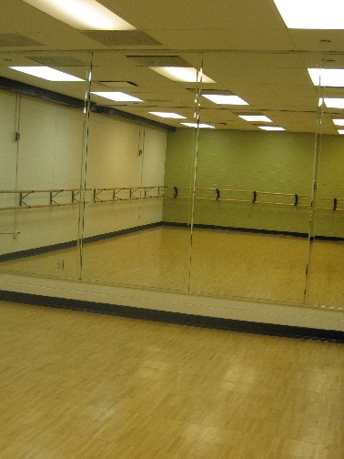
Off-Ice Group Classes

Our off-ice group classes create an environment where the understanding of movement and performance is explored in harmony with the art of figure skating. Our off-ice instructors collaborate closely with on-ice instructors to cross-train athletes so that they may become outstanding performers through creativity, discipline, knowledge and technique. All classes focus attention on bodyline, placement, kinesthetic awareness and professional attitude.

In all classes, skaters will be required to dress appropriately. Ballet or jazz shoes are required. Tennis shoes are not permitted in the Dance studio. Male skaters may wear skating or jazz pants, female skaters a skating dress or tights.

Ballet
Description: Ballet is fundamental to the development of any skater. Ballet helps to develop lower-back strength, upper-body grace, flowing arm movement and the requisite strength, flexibility and endurance needed during a figure skating performance. Our ballet classes are designed for figure skaters to emphasize correct hip placement, strong center alignment, improved elevation, flexibility and fluidity of line, and confidence of movement.

Stretch
Description: This class teaches skaters how to use different types of stretching for their individual needs. Stretching in skating is absolutely essential. Flexibility is a key component in figure skating and also aids competitors with endurance, mental alertness, relieving stress and decreasing muscle soreness. Stretches should be done both before and after skating helping to prevent injury while exercising and serve as a great recovery after a workout.

Performance and Interpretation
Description: At figure skating competitions, a portion of your scores are based on the program components of Performance and Interpretation. Ice skating competitions can win or lose an event based on the points earned from these very important skills. This class works on Performance and Interpretation, using different styles of music, body language, and facial expression to improve competitors’ scores.

Off-Ice Jump and Spin
Description: This class is designed to help skaters become physically prepared to learn jumps and spins on the ice. Class includes but is not limited to jumping warm up exercises, strengthening the four major groups of muscles, working on quickness and coordination, and learning basic jump and flying spins technique. Spinners and jump ropes are recommended, but are not mandatory for this class. If necessary, part of the class may take place outside of the ballet room.
Ice Etiquette Guidelines

THIS IS A ZERO TOLERANCE POLICY

Failure to comply with the following policies shall result in removal from the ice and a loss of privileges in the World Arena Ice Hall for the remainder of the day.
In the event of any such action, there will be no refund or credit for lost sessions.

- Skaters are required to check in with the ice monitor before beginning their session.
- Food and/or drink are not permitted on the ice (exception – plastic water bottles).
- It is the responsibility of all skaters to keep the ice clean and free of trash and other belongings such as water bottles, gloves, etc.
- No stopping or standing on the ice except against the boards. This also includes speaking with people in the bleachers or at the rink doors. If it is necessary to speak to anyone other than a coach off the ice, skaters must step off the ice.
- PARENTS are restricted to the bleachers for viewing at all times. Parents are not allowed on the Player’s Bench side of the rink.
- Any parent observed instructing a skater (including using gestures from bleachers) will result in the removal of the parent and the skater from the rink. There will be no refund or credit for unused sessions or classes.
- Kicking the ice or boards, shouting, foul or abusive language or arguing with other skaters or coaches will not be tolerated.
- Skaters must skate the sessions at their confirmed level. Skaters must have passed the freeskate portion of that level – not moves in the field.
- At the end of the session, skaters must leave the ice promptly.

Close By Conveniences and Hotel Accommodations

The World Arena Ice Hall is nearby to the Cheyenne Mountain Shopping Center which is bustling with restaurants, hotels, retail stores and a movie theater. Each skater is solely responsible for arranging his/her housing while attending Summer Skate. Below is a listing of hotels within walking distance of the World Arena Ice Hall.

Doubletree World Arena La Quinta Inn and Suites South
1775 E. Cheyenne Mountain Blvd. 2750 Geyser Drive
Colorado Springs, CO 80906 Colorado Springs, CO 80906
(719) 576-8900 (719) 527-4788

Fairfield Inn by Marriott South Residence Inn by Marriott South
2725 Geyser Drive 2765 Geyser Drive
Colorado Springs, CO 80906 Colorado Springs, CO 80906
(719) 576-0101 (719)-576-0101

Hampton Inn and Suites I-25 South
2910 Geyser Drive
Colorado Springs, CO 80906
(719) 884-0330

